Name _______________________________Block _____ / _____ Date Due __________
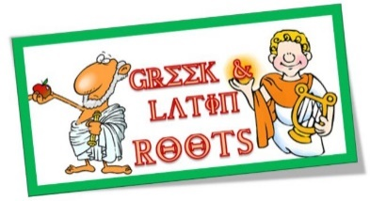
GREEK AND LATIN Root Words ONE-PAGER
- All work must be on one side of the page!
- Start with a border that INCLUDES words containing the 10 roots.
- Draw a visual image or find a clip art picture that depicts each root accurately. You may also choose symbols that convey an idea about the root.
- Be colorful and neat. Your entire page should be filled. All pictures must be neat and colorful! Use different colors to make each one stand out!
- Use unlined white paper. Teacher will provide the paper.
 | (4) Advanced | (3) Proficient | (2) Developing | (1) Emerging
Effort | - Project is completed and turned in on time. | - Project is completed on time. | - Project is completed one day late. | - Project is completed more than one day late.
Content | - Student defines all 10 roots accurately.  - Illustrations are well thought out and reflective of the root meaning. | - Student defines 8-9 roots accurately.  - Illustrations are reflective of the root meaning. | - Student defines 6-7 roots  accurately.  - Illustrations are somewhat reflective of the root meaning. | - Student defines 5 or less roots accurately.  - Illustrations are missing or incomplete.
Organization/  Appearance | - All requirements are complete and organized on the page.  - Student work is legible, neat, and very colorful. | - All requirements are complete on the page.  - Student work is legible and colorful. | - Most of the requirements are complete.  - Student work is legible, but sloppy at times, or not colored. | - Some of the requirements are complete.  - Student work is illegible, sloppy, and/or not colored.
Language/  Conventions | - No spelling errors  - No capitalization errors | - 1 spelling error  - 1 capitalization error | - 2 spelling errors  - 2-3 capitalization errors | - 3 or more spelling errors  - 4 or more capitalization errors
 | 10 9.5 9  A+ A A- | 8.5 8  B B- | 7.5 7  C C- | 6.5 6  D D-

